Primary logo

Our primary brand logo for FOQA is displayed here. The primary logo features the world, trendlines, and the wordmark in English only
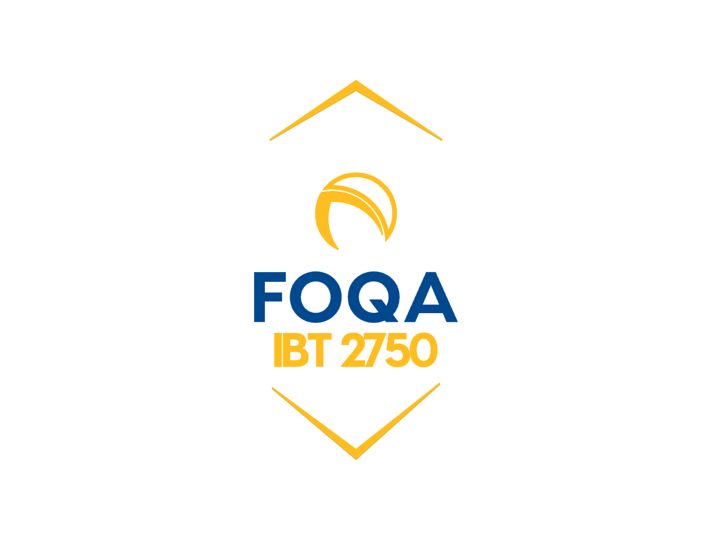
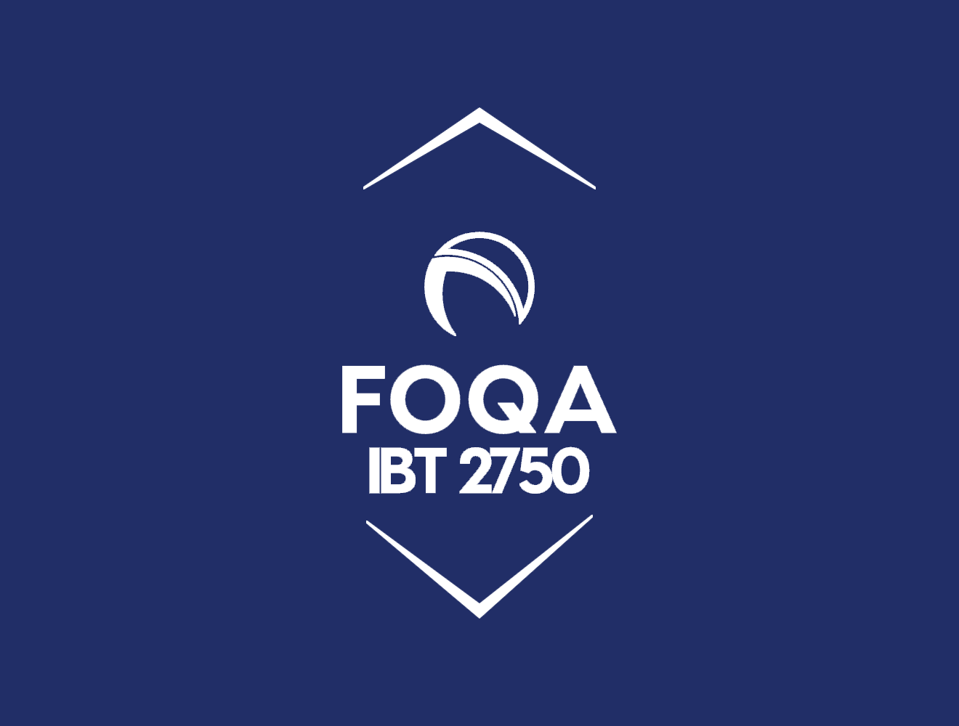


Logo colour

Teamster Blue is our primary colour. The HEX colour values of our corporate colour are given below. Use these values only and do not attempt to recreate. If inverting the logo, the logo should appear in Blue or Gold over our Teamster Yellow and Teamster Blue.

